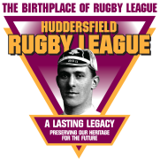 Theme 1

How Rugby Football Came to Huddersfield:
Developments in Rugby Football

Pupil Resource Sheet

Source A

Until 1863 football and rugby were not separate sports. Lots of different versions of football and rugby-type games, all known as football, were played.

No-one knows when the first games of football were played, but we know that football-type games were played by ancient civilisations.

About 200 B.C. the Chinese played ‘tsu chu’, a game which involved kicking a ball shape. The Ancient Greeks played a ball-handling game that involved scoring ‘goals’ called ‘episkyres’. The Romans played a similar game called ‘harpustum’. In Central America the Aztecs played ‘tlatchli’, a game involving volleyball, basketball and football-type skills.

It is likely that some games spread through people emigrating or visiting different places and that some games developed separately. Britain was invaded so frequently between the arrival of the Romans in 43 A.D. and the Normans in 1066 that it seems likely that football-type games were brought to these shores by invaders.

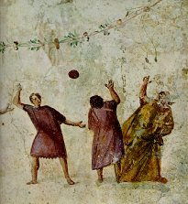
Romans playing harpustum

Source B

The early football played in the Huddersfield area and other places in Britain was ‘mob football’, also called ‘folk football’. Mob football was mostly played by small groups of men or boys. On special occasions there were many players on each side, sometimes village versus village.

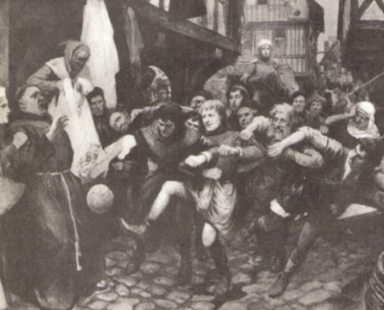

There were hardly any rules and the aim was to get the ball through your opponents’ goal by any means possible. In village versus village matches the goals could be miles apart. Matches often resembled a riot and there were many injuries and some deaths.

At first these games were mostly played in fields, but as towns grew in size mob football was sometimes played in the streets, causing damage to property and blocking the highway.

In 1314 King Edward II banned football in London and several kings who followed him made similar decrees. By the 1800s many places were growing in size and the Highways Act of 1835 banned football on all public roads.

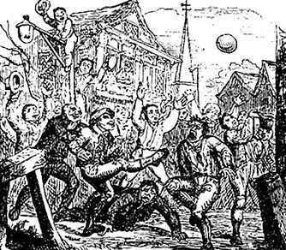

Writing in 1886, a journalist described his memories of mob football in Hebden Bridge in the 1820s:
‘lively and fierce contests of sometimes twenty, thirty, forty or fifty players on a side on the fields and streets ... there was no quibbling about tries, or mauls, or ‘offside’ play. A fence at either end was designed as the goal, and each player strove like the apostle Paul, to keep “the goal in view” … just imagine the hubbub and confusion.’

There were mob football-type kick-abouts in the streets and fields around Huddersfield in the 1840s, and probably much earlier.

The first recorded match in the Huddersfield district is between Holmfirth and Hepworth at Whinney Bank in 1848. Hepworth won among ‘the usual amount of contusions, bloody noses etc’.

Source C

More organised forms of football, with rules, were introduced to towns across the north of England by young men who had played them at public school.

Football was played at public schools in the early and mid-1800s, mainly as a way of teaching boys how to play fairly and to play to the rules. They would then know how to be fair and obey the rules in everyday life, an idea called ‘Muscular Christianity’.

Many public schoolboys wanted to carry on playing football when they returned home to towns such as Huddersfield. Needing others to play with and against, they taught the game they had learnt to local men.

The rules limited how players could move the ball and challenge opponents. Compared to mob football, they made football safer, more skilful, more interesting and more enjoyable.

Source D

The public schools all had their own rules and played their own versions of football. The many different versions of the football led to teams from different places playing to different rules. For matches between teams from different places to be played fairly, rules were needed that everyone could understand.

Sheffield Football Club, the oldest football club in the world, was formed in 1857 and wrote rules by which its members would play. Many of the Sheffield rules were included in the first rules of football, written by the Football Association when it was formed in 1863. Among these rules, carrying the ball was not allowed, although any player was still allowed to catch it. Passing the ball forward to a team mate was also not allowed.

Some English clubs and public schools disagreed with the Football Association’s rules. They broke away to play their own forms of the game. This led to the formation of the Rugby Football Union, which wrote the first rules of rugby being written in 1871.

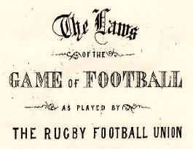

The rules of both football and rugby would be changed many times in the coming years but there were now two winter team sports with rules that everyone could understand. It took time for the rules to be passed on and understood - in some places men played to their own rules for several years - but gradually it became easier for teams from different places to play matches against one another.

Source E

Nearly all football/rugby clubs in the north of England, including the Huddersfield district, were formed by one or more of:

- young men who had been to public school and/or university
- boys and young men organising sporting activity for themselves
- men who worked in the same place forming a team
- men from an existing cricket or athletics club looking for a winter sport to play together
- the local church organising sporting activity for its followers.

The club that is now Huddersfield Giants Rugby League Football Club was formed from the Huddersfield Athletic Club, which was founded in 1864.

This is how it happened. In 1850, Professor John Le Blanc opened the Apollo Gymnasium. In 1864 the local Volunteer Rifle Corps took over Huddersfield’s only theatre as a drill hall and armoury, so Le Blanc turned his gymnasium into a theatre.

Young athletes were disappointed at losing their gymnasium. On 16 November 1864 they met at the Queens Hotel, Market Street, and founded the Huddersfield Athletic Club. They set up their own gymnasium on Back John William Street and began to organise athletics festivals.

In the winter, Huddersfield Athletic Club played football. Following a match against the Rifle Corps in the autumn of 1866, the athletics club set up a rugby football section at their Annual General Meeting that December.

For a couple of years matches were played on three fields: the Rifle Field on Trinity Street; Field House on Leeds Road; and The Grove, at Springwood. In 1868 Fartown, owned by the owner of the George Hotel, was opened as a cricket and football ground.

In 1876 the athletics club joined with St John’s Cricket Club from Hillhouse to form the Huddersfield Cricket and Athletic Club. The club’s main sports were rugby, cricket and athletics.

Source F

In 1871 a national knockout competition, the FA Cup, was founded and it was a great success.

It was copied in 1877 by rugby’s Yorkshire Cup. Known as ‘th’ ‘owd tin pot’, the trophy was presented to the Yorkshire County Committee by Yorkshire’s five main clubs at that time – Bradford, Huddersfield, Hull, Leeds and York. Huddersfield entered rugby’s Yorkshire Cup from its first season in 1877.

Amateur cup competitions followed. In 1883 the Heavy Woollen Cricket Cup, the oldest cricket knockout competition in the world was founded. It was followed in 1885 by the Holliday Cup, a competition for Huddersfield’s amateur rugby clubs. The trophy was presented by Mr Charles Holliday, the President of the Huddersfield Cricket and Athletic Club.

Cup matches had two major effects on football and rugby:

1. So that competitions were fair, teams had to play to the same rules, so common rules were spread more quickly.

2. Cup matches were very popular because the matches counted towards something bigger than just that game, giving them a wider context. They attracted big crowds and lots of gate money.

Source G

One disadvantage of cup competitions was that once a club lost (was knocked out) it had no more games in the competition.

Clubs soon wanted to play more matches that generated the excitement, interest and money of the cup competitions – more matches that had a wider context.

This is why leagues replaced friendly matches. Points were awarded for wins and draws to give league matches their wider context, allowing fair comparisons between clubs.

In 1888 the Football League was founded. It was a great success and was soon copied by the formation of many other leagues in rugby, football and cricket.

The Scottish Football League was formed in 1890. The first football league for football clubs in the south, the Southern League, was set up in 1894. Cricket’s county championship was organised on a league basis in 1890. The Huddersfield Cricket League began in 1891 and the West Riding, West Riding Central and West Yorkshire cricket leagues all began between 1892 and 1896.

The first league in rugby, the Yorkshire Senior Competition, was set up in 1892.

Source H

Some of those who ran rugby union, particularly in the south, disagreed with cups and leagues. They believed it would encourage players to play unfairly and ‘win at all costs’ – against the spirit of Muscular Christianity.

To encourage fair play, payments of any kind to players were banned. This included ‘broken time pay’ that made up for wages that players lost when they left work early to play. This seemed unfair when thousands were paying to watch their matches.

On 29 August 1895, 22 northern clubs met in the George Hotel, Huddersfield, and voted to break away from the Rugby Football Union. They set up the Northern Rugby Football Union so that they could allow ‘broken time pay’. The break-away of the Northern Rugby Football Union was the birth of rugby league, although northern union would not be called rugby league until 1922. Among the 22 clubs that broke away was Huddersfield.
The full list is:
Batley
Bradford
Brighouse Rangers
Broughton Rangers
Halifax
Huddersfield
Hunslet
Hull
Leeds
Leigh
Liversedge
Manningham
Oldham
Rochdale Hornets
Runcorn
St Helens
Stockport
Tyldesley
Wakefield Trinity
Warrington
Widnes
Wigan

